Bash is an sh- compatible command language interpreter that executes command reads from the standard input or from a file.

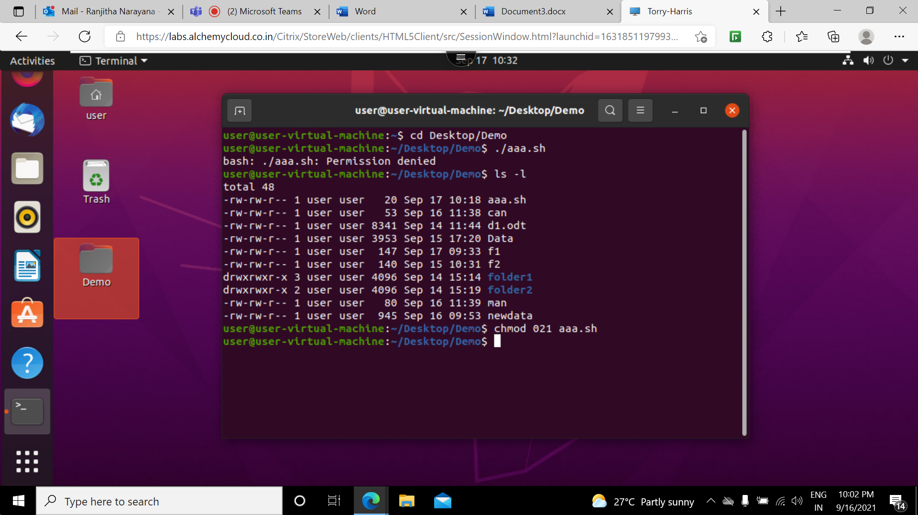

**chmod** command is used to change the read write and executable commands of the file.

Here **chmod 777 filename** syntax is used to make a file or folder permissions accessible to everyone.

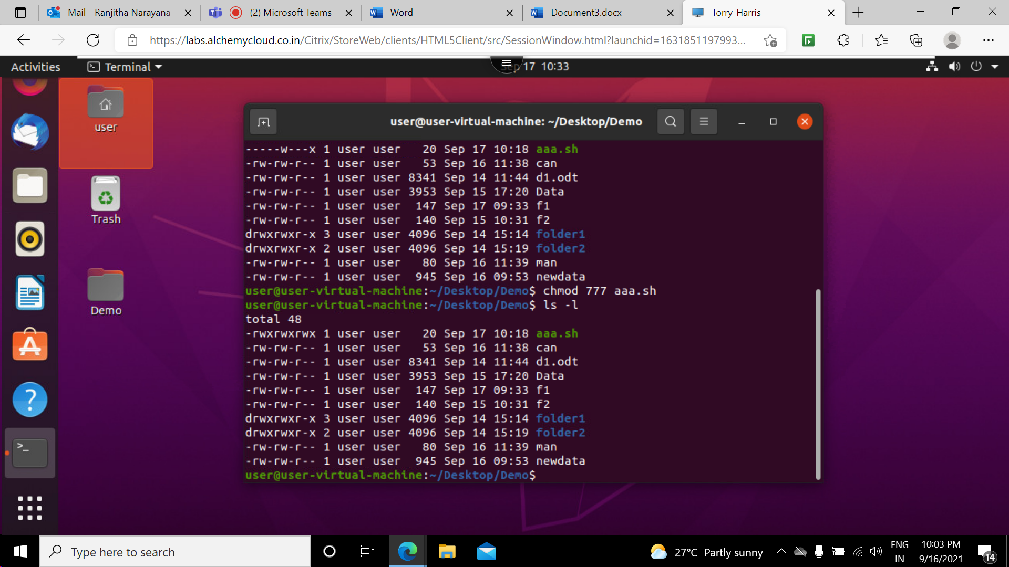

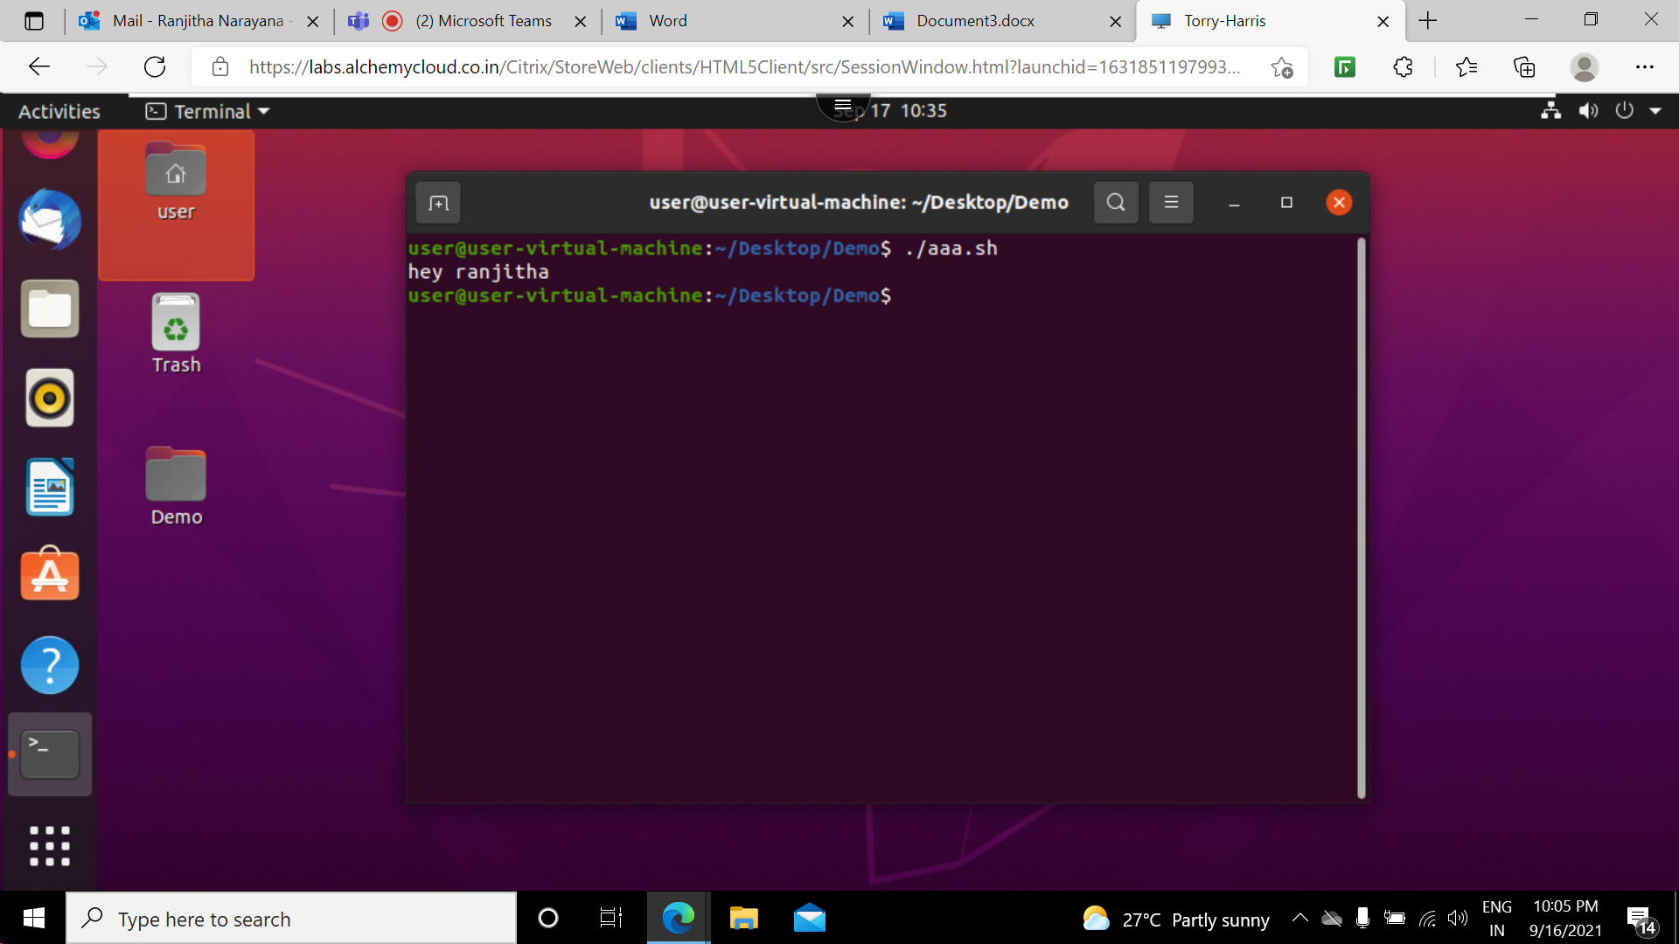

**echo command** is used to display a line of text that is passed in as an argument

Used in shell scripts to output status to the screen to a file.

# following any sentence is considered as comment and it will not be executed .

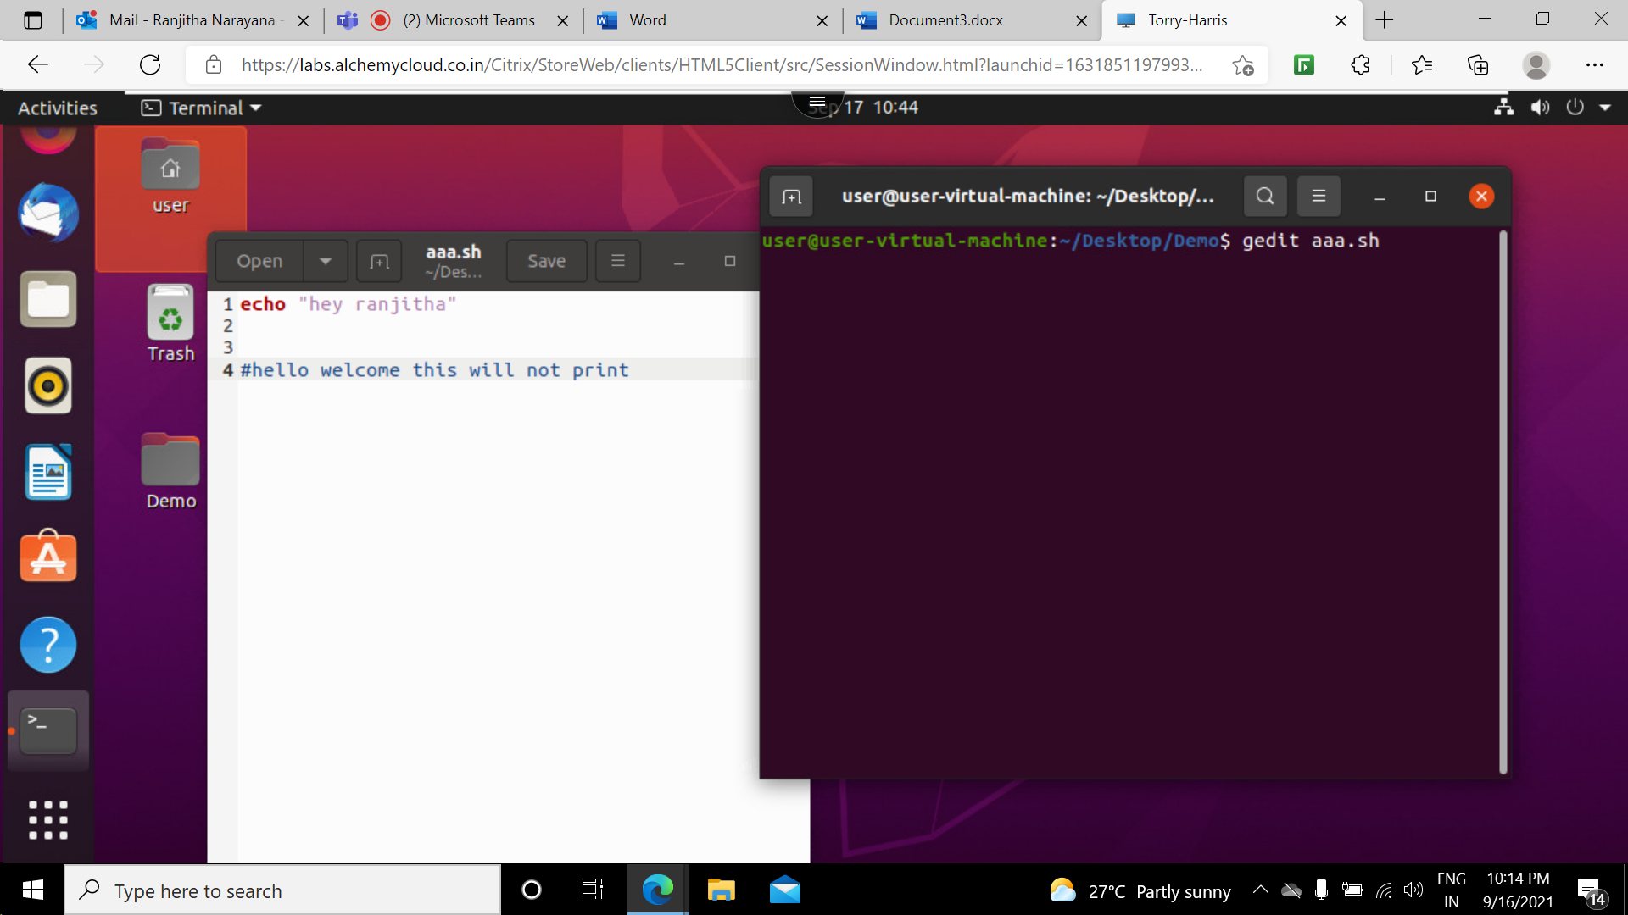

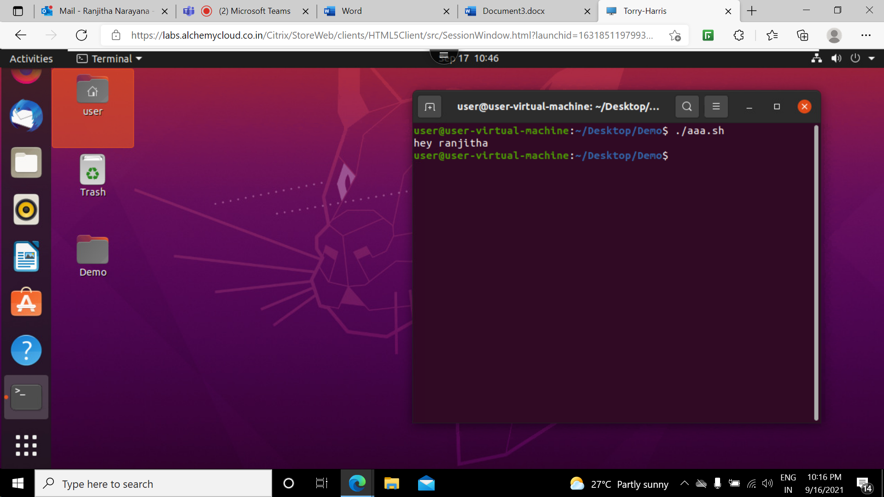

We can make use different commands like mkdir to make directory, touch to create file ,echo to print

Within sh file .In below image I have created directory named “ranjitha” and within directory I have created one file named bbb.

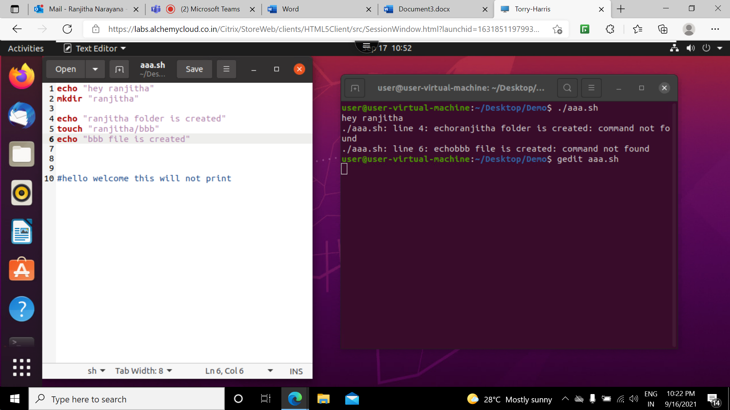

The below image shows the created folder and file

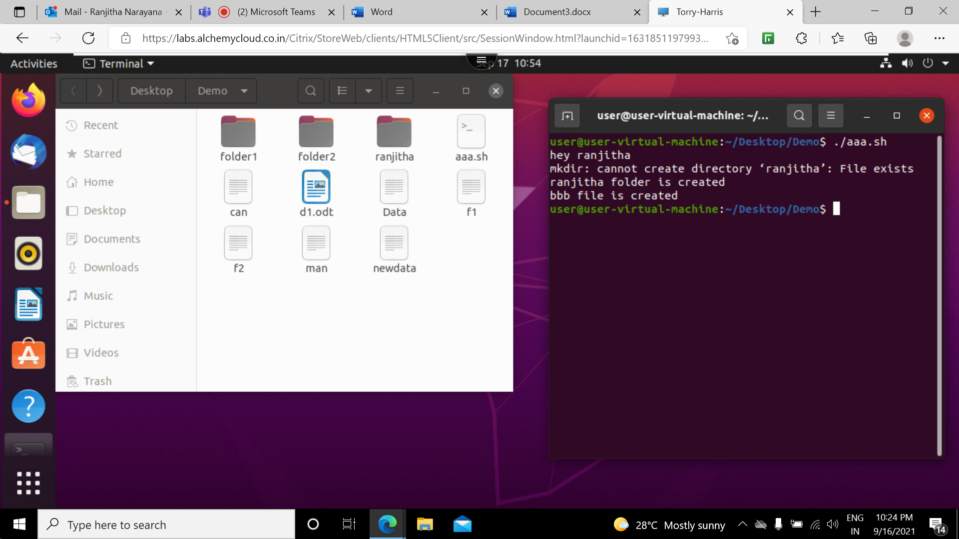

Other way to create file with data by using echo we are printing some data to bb.txt file

Here > is redirects the output of given command to file bb.txt.

